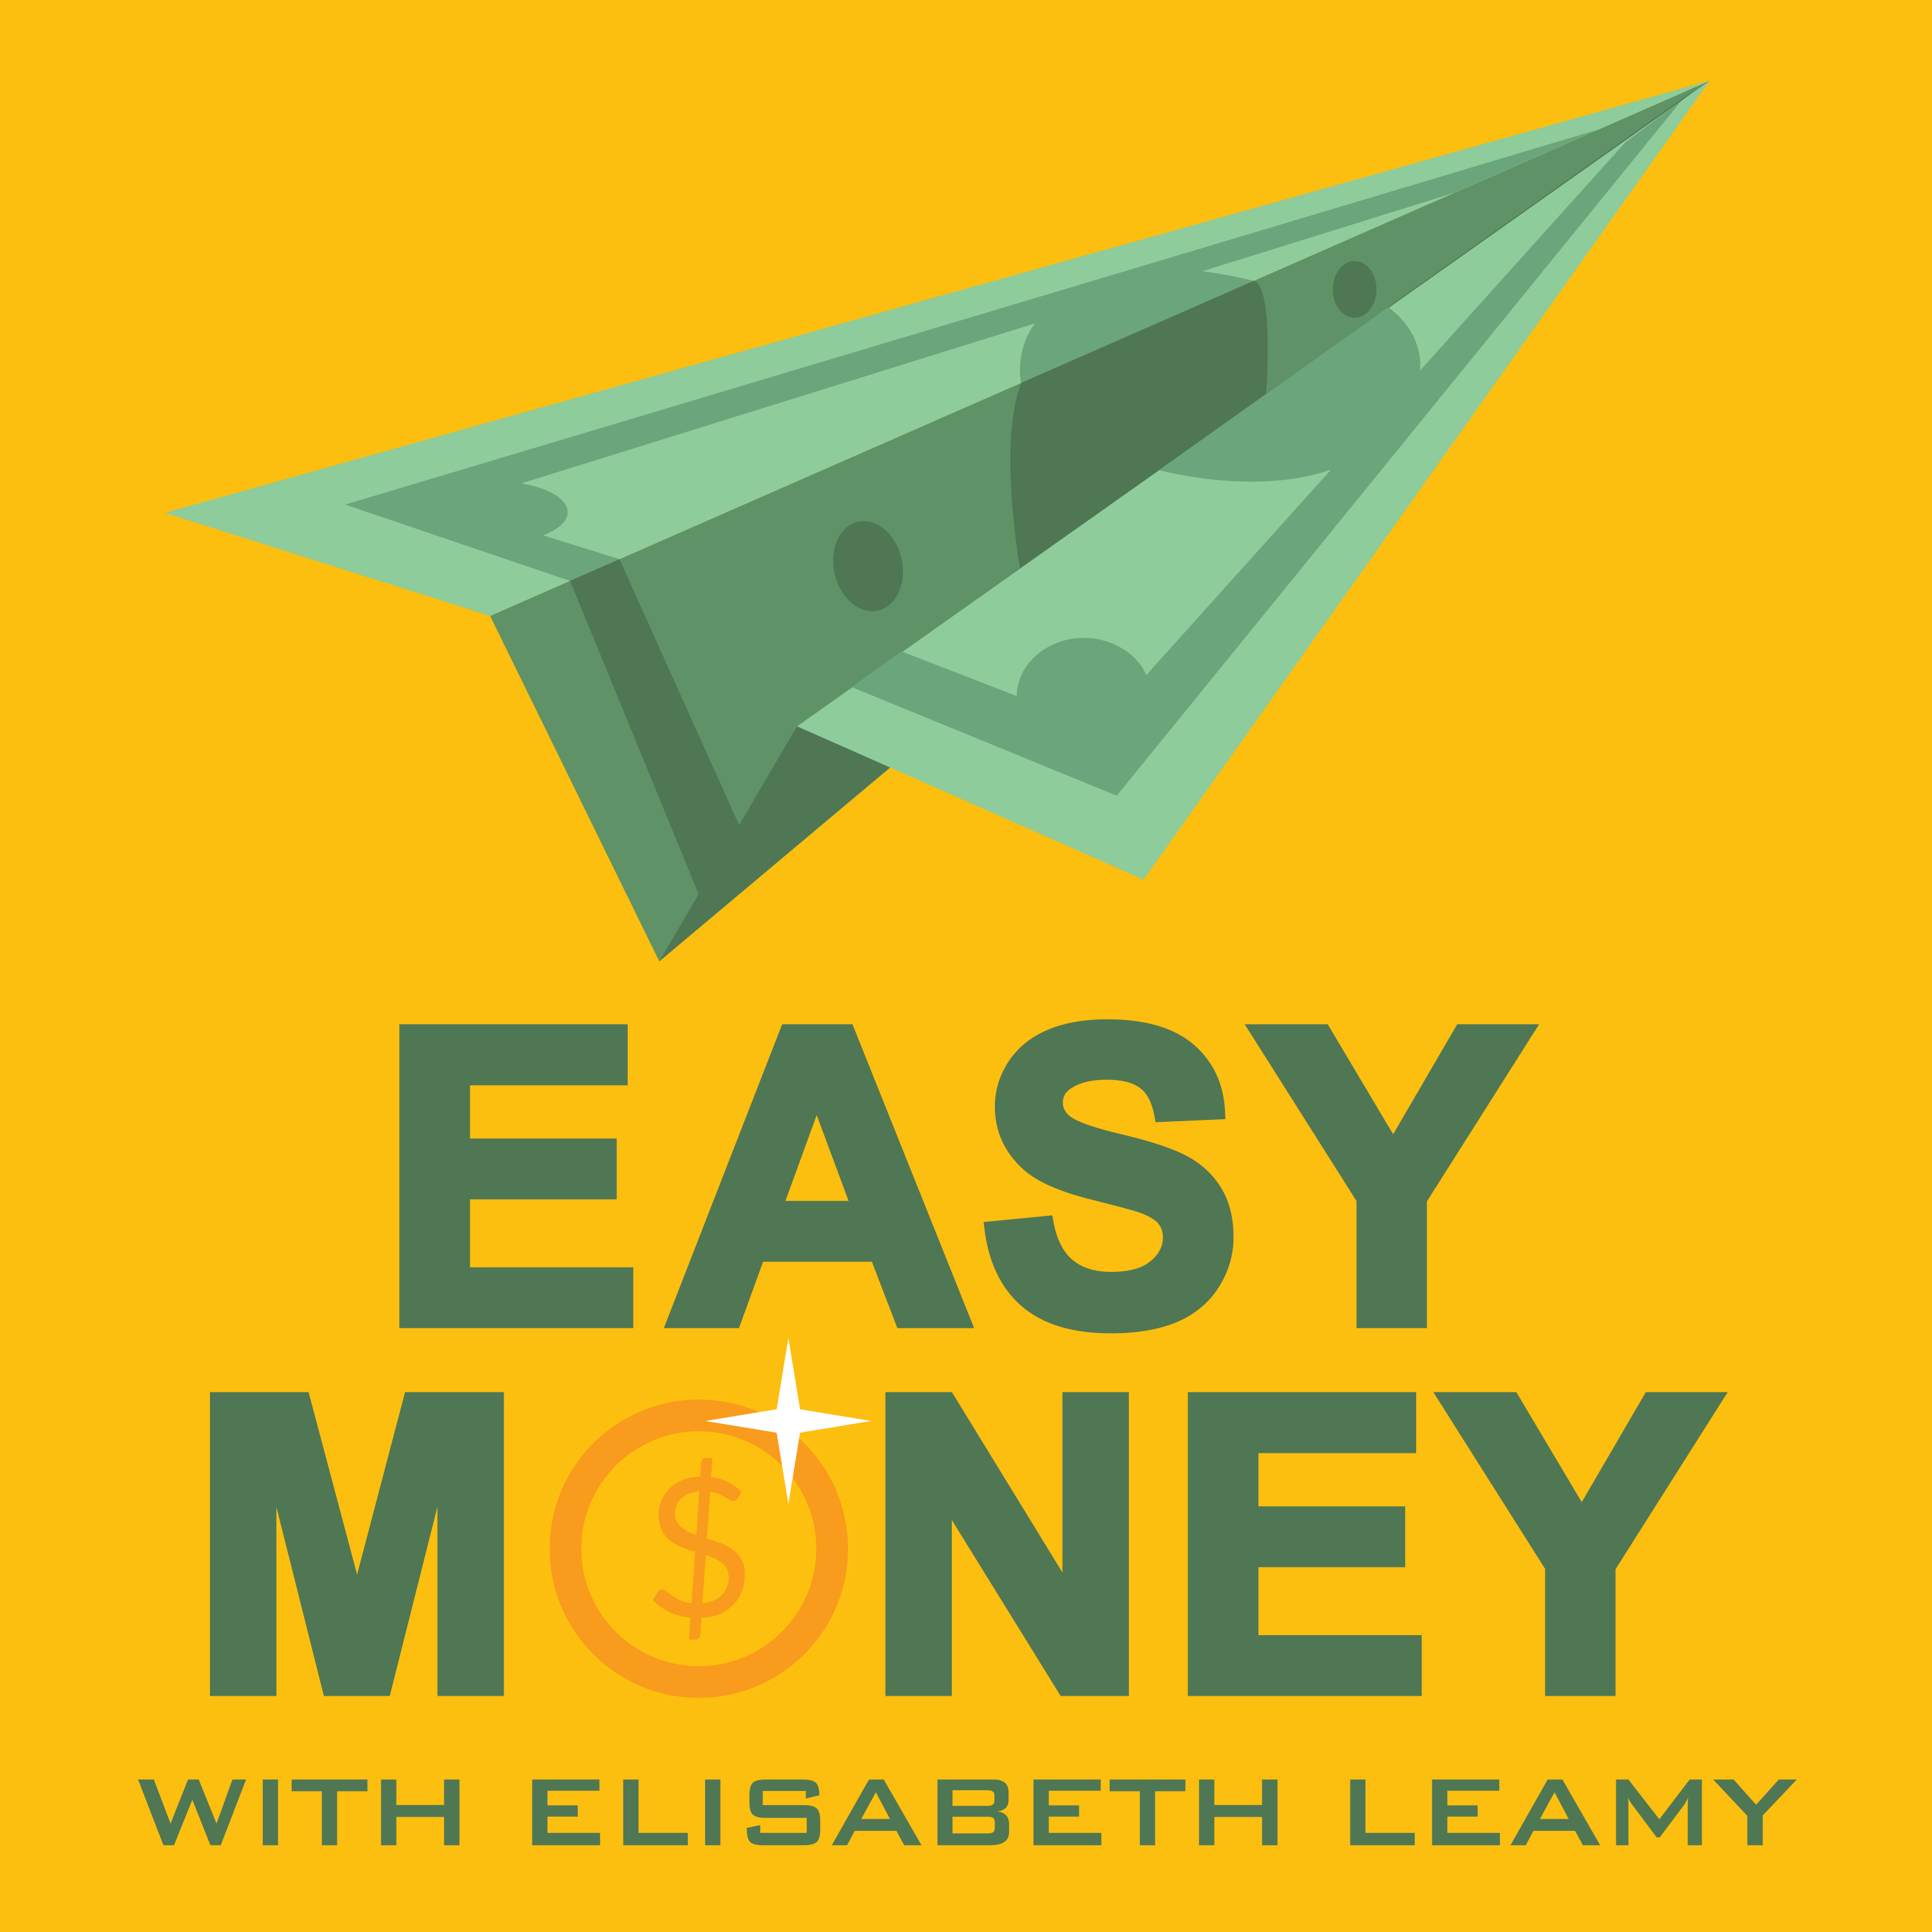

For Immediate Release Contact: Elisabeth Leamy (202) 276-7444
Elisabeth@ElisabethLeamy.com

Best Websites to Work From Home
Award-winning Print/Broadcast Journalist Elisabeth Leamy Interviews Guests with Inspiring Home Business Success Stories on New Podcast “Easy Money”

WASHINGTON, D.C., November, 2017 – Charmaine Pocek of Houston has made more than $1.2 million dollars editing resumes for online clients. Back in 2013, she was a successful recruiter and started the online work to make extra money so she and her husband could adopt a baby. Not only did Pocek raise the money needed, she found she was making far more from her side gig than her day job. Pocek quit recruiting and says the online work gives her all the flexibility she needs to spend time with her baby girl. “It has changed our life,” Pocek said. “We travel four to five times a year. That is the best part. We take our computers and work from a cruise or Disneyland.”

Ryan Heenan of Orange County, California used to make $30,000 a year as a preschool music teacher. Now he makes $30,000 a month producing jingles and videos businesses order from him online. “I have turned my passion into a business and it doesn’t feel like work,” Heenan said. “Most of my friends work normal 9 to 5 jobs and are excited for a promotion in 10 years, when I can be excited for something that happened today.”

Both Pocek and Heenan have found this work-at-home success through Fiverr, an online marketplace that connects freelancers with clients. One reason customers are plentiful is that many services on Fiverr cost just $5, as the name suggests. Successful Fiverr sellers parlay those $5 “gateway gigs” into much higher-paid contracts, making it one of the best websites to work from home.

Fiverr is just one of the work from home websites featured on the Easy Money Podcast. Others —like Instagram, Skillshare, Poshmark, and Turo— are also helping people make good money from home. How much? Every week, host Elisabeth Leamy asks that taboo question so listeners can figure out if her guests’ ventures might work for them.

Other work from home success stories featured on Easy Money:
- Military mom Candace Hatch didn’t even know how to sew when she started making her Lili Lane children’s clothing. Celebrities spotted her quirky creations on Instagram, and Hatch was even asked to include her clothing in Oscar gift bags.

- Instagram is also key to 27-year-old Alicia Chew’s success. Chew started a fashion blog in her dorm room and built up such an impressive following that brands from Banana Republic to Pepsi pay her to talk up their products. “It’s the dream job I never knew I could have,” said Chew.

- For Jake Bartlett, teaching online was the answer and Skillshare was the platform. He was working as a motion graphics producer, so he created a course to teach other people how to do what he did. It was such a success that he quit his job. “I realized my day job was taking away from my freelance career,” Bartlett said.

- Necessity breeds invention, and when Jessica Craddock’s fiancee got injured and was unable to work, she had to step up. She started selling clothing on Poshmark, the popular fashion app. Craddock was a law student at the time and has half considered skipping a law career because her Poshmark business is doing so well.

- Kyle Clark couldn’t stand to trade in his old car for next-to-nothing, so he looked around for something to do with it. Enter Turo, “the AirBnB of cars.” Clark rented the old Honda Civic out on Turo and it was booked solid. Today he has a fleet of eleven rental vehicles. Last year he used his Turo profits to travel around the world.

A third of every Easy Money podcast is devoted to stories about how to make more money. Leamy wanted to go beyond the “what NOT to do” stories she had to cover as Good Morning America’s consumer correspondent and show people the tremendous potential now out there. “The phrase ‘legitimate work-at-home opportunity’ used to be an oxymoron,” said Leamy. They were all scams! But now, thanks to the internet, you can make a great living from home.”

About The Easy Money Podcast and Host Elisabeth Leamy:
Every week on Easy Money, 13-Time Emmy-winner Elisabeth Leamy (Washington Post, Good Morning America, Dr. Oz) uncovers clever, creative ways to make more money, save more money and find your unclaimed money. Her goal is to make understanding money easy —not hard. By utilizing this story idea, you will be getting quality FREE content, while helping an ad-free, educational podcast. Download all story materials at: EasyMoneyShow.com/press-kit.

Easy Money Podcast Links: (Please include these links on your website in exchange for use)
Easy Money on iTunes: http://apple.co/2tpUY6v
The Easy Money Show website: EasyMoneyShow.com

TAGS:
Work from home, best sites to find jobs, online jobs, working from home, make money online, jobs from home, earn money online, online jobs from home, online work, home based jobs, legitimate work from home jobs, online jobs work from home, how to make money from home

